Influence of resolution and cropping techniques in image classification

Filipe Miranda
Faculty of Engineering of University of Porto
ei12021@fe.up.pt

ABSTRACT
In this paper, we will be going through the impacts of resizing and cropping in class categorization. This Categorization will be achieved by training a classifier with a set of images for each class and then apply it to a test set, where the accuracy of the method will be measured as the number of correct classifications. The training will be executed using several configurations and different resizing and cropping techniques.
General Terms
Algorithms, Performance, Experimentation, Factors.

INTRODUCTION
Image classification has been an area of intense interest over the past years. With the proliferation of photography with smartphones and wide access to the internet, image classification for both search and recognition of the world through a camera lenses has never been more important.
With this paper, we will be exploring the impacts of resizing images and cropping techniques with a model for image categorization using the Bag of Visual Words.
With the resizing of images, there are several possible outcomes: if one decides do reduce the resolution of an image, it could end up with a smaller file that could perform in a better, even or worse way as the original file to train and test image classification.
Reducing the file size can be a priority for systems where storage space is scare or decreasing the running time. On the other hand, we might be tempted to enlarge our images to perhaps get better results in classification.
Another approach to improving classification could be just to analyze a portion of an image, improving the running time of training and testing. In this research, all of the cases described above will be tested and compared.

RELATED WORK
Image classification is a recurrent subject in several scientific papers due to its interesting and useful applications. Categorization by the means of the Bag of Visual Words has already been explored and tested [1], proven to be a viable method for categorization of images. The method used in this paper will be heavily based on this approach, where we start by extracting features from the images and construct in ways of a vector an histogram of each image, then we train a classifier with positive and negative images for each classifications and then we apply this trained classifier to the test set, measuring its accuracy.
Image interpolation techniques have already been explored as well, being described and compared with each other [2]. Although, there hasn’t been any investigation on the impacts of interpolation techniques neither cropping techniques on the performance of categorization using Bag of Visual Words.

Approach

Classification Approach
For image classification, as stated before, we will base our method in the one presented in [2], which relies on the bag of visual words. The bag of visual words is a method that represents an image through the means of a vector made up of visual words and its frequency.
To achieve the definition of a visual word, we first need to find the interest points of each image. This keypoints are defined as salient image patches containing distinctive features that are used to categorize an image. Keypoints usually are found in the corners and edges of image objects. For this detection, it was used the Difference of Gaussians detector [3], that increases the visibility of edges and other details through the subtraction of one blurred version of the image from another, less blurred. For the description of our images it was used the Scale-Invariant Feature Transform (SIFT).
After the keypoint detection and description, a clustering process is needed so we can group similar patches into a single visual word. The clustering process generates a dictionary of visual words that will then be used to describe each image through a histogram of visual words (Figure 1). This histogram is represented as a vector of “visual words” and its frequency or absence of it in an image file.
Visual words are representations of parts of an image, distinctive features that are used to categorize the image. For the feature descriptors of our images it was used the Scale-Invariant feature transform (SIFT).
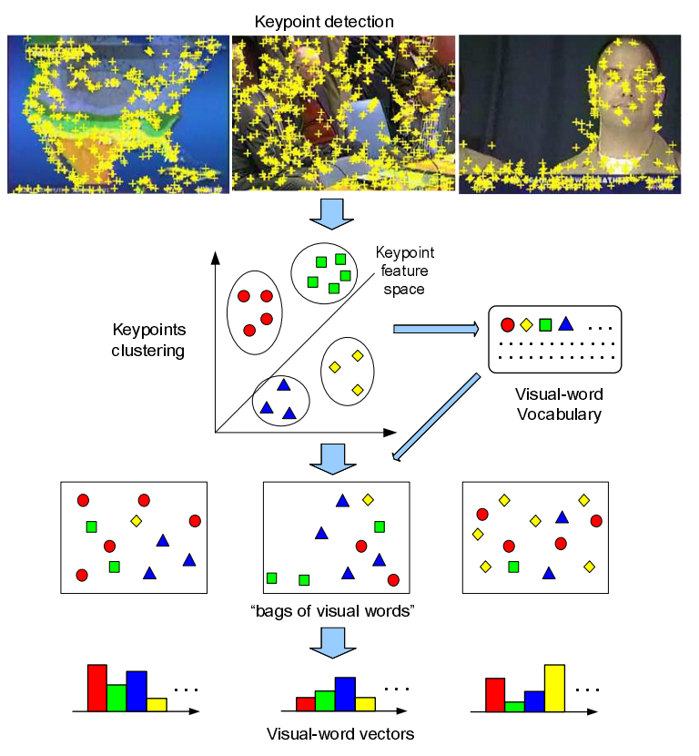
Figure 1. Bag of Visual Words process from Keypoint detection to Visual-word vectors [1]

Resizing approach
Interpolation is the act of resizing or distorting an image from one pixel grid to the other. It is needed to increase or decrease the total number of pixels in an image, using known data to estimate values at unknown points. This resize can be achieved by several algorithms [2], known as interpolations. There were used four types of interpolation to test the results of rescaling in this paper:
Nearest neighbor interpolation – In this method each interpolated output pixel is assigned the value of the nearest sample point in the input image. Although this method is very efficient, the quality of image is very poor, that is, the smoothness of objects is lost.
Bilinear interpolation – This interpolation method is used to determine the new set of pixels, considering the weighted average of the four closest pixels of the input coordinates to the new output. This interpolation results in smoother looking images than the ones retrieved from the Nearest Neighbor interpolation.
Bicubic interpolation – The bicubic interpolation is an improvement over the bilinear interpolation, once it uses a four by four grid of pixels centered on the input coordinates to determine the new output. The weighted average of the 16 pixels assigns a bigger weight to closer pixels and a smaller weight to further pixels.
Sinc (Lanczos) interpolation - The sinc or lanzcos interpolation maps each sample of a given signal to a translated and scaled copy of the Lanzcos (windowed sinc function) [2]. It is also considered to be a slower process than the other interpolation methods presented

To understand the effects of resizing, there were taken into account two resizes for this study: a 50% and a 150% resize. With this approach, we can compare the accuracy results of both the downscale and upscale image with the original one (Figure 2).
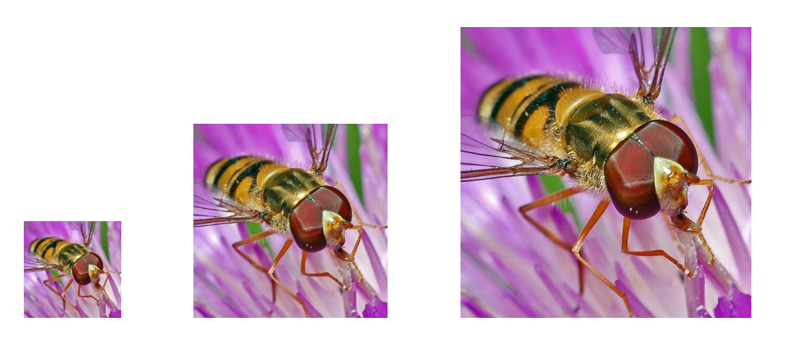
Figure 2. Resizing of the same image, from left to right at 50%, original scale and 150%.

For each resizing, there were made four datasets and testsets for all the four interpolations presented before. The resizing of images was done using a batch plugin for the GNU Image Manipulation Program (GIMP) called Batch Image Manipulation Plugin (BIMP). This plugin allows us to perform resizing using several interpolation methods on a large dataset.

Cropping approach
For the cropping approach, the idea was to evaluate how categorization is affected when restricted to a certain are on an image. Positive results such as even or improved accuracy could be used to decrease the training running time only evaluating part of an image. I decided that that a crop of aspect 1:1 would be the best approach to begin with. The cropping was made in three ways: the aspect ratio centered on the image, on the left and on the right of the image, ending up with 3 datasets (Figure 3).
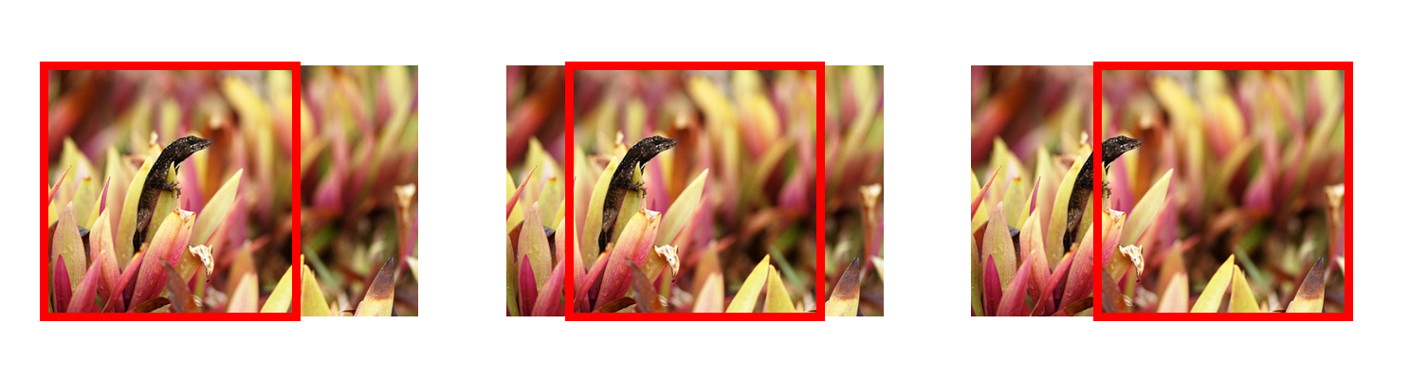
Figure 3. Cropping with an aspect 1:1 on left, center and right of an image
Once again, the BIMP plugin was used in conjunction with GIMP to generate the datasets and training sets.

EXPERIMENTAL SETUP AND RESULTS

Dataset
To perform the experiments in this paper, the MIRFLICKR25000 database provided by the LIACS Medialab at Leiden University, The Netherlands. This database has 25,000 Flickr images under the Creative Commons license [4] with different resolutions and aspect ratios.

Experimental setup
To be able to compare our results, we first have to define the environment in which the experiments where taken. There were trained 21 categories, each one assigned with 50 images. Our test-set was made up of 700 images.

Dictionary size

The dictionary size affects how much a classifier learns either an object or a class of objects. A small sized dictionary will not be able to train its classifiers adequately, while a large sized dictionary will target determinate objects instead of class of objects. To understand how the dictionary size would influence the results, the number of visual words int the dictionary was varied with the following values: 50, 100 and 300. Although this number of words is actually small for good results[1], there had to be a compromise due to the exponential running time increase with the increase of the dictionary size.

Experiments and Results

Resizing

The first experiment made was using 50 words as a dictionary size. This dictionary size is not very relevant once is relatively small when compared with the number of classes involved. This test served mainly to first observe how the program would run and if it was successful or not it's execution. The base accuracy is 64/700=9.1%. It should be said that 9.1% of accuracy right of the start is not a good result. Once we are dealing with 21 categories and each image has more than one word, the percentage resulting from the original files is not very promising.
As we can see in Table 1 the results are not very promising, once they all approximate to the base probability. The next approach was to increase our dictionary size to 100. The best result in this experiment was downscaling our images by 50% using the Sinc interpolation method, scoring 10.3% of accuracy (an increase of 1.2%).
Table 1. Resizing experiment results with a dictionary size of 50 visual words
 | 50% | 150%
Nearest Neighbor | 55 | 7.9% | 67 | 9.6%
Bilinear | 67 | 9.6% | 64 | 9.1%
Bicubic | 63 | 9% | 70 | 10%
Sinc | 72 | 10.3% | 63 | 9%

In Table 2 we can see the results of the same experiment presented above now with a dictionary size of 100 visual words. As we can see, there is a clear discrepancy between the results obtained from downscale images, comparing with upscaled ones. The accuracy obtained with the original files, using 100 visual words as the dictionary size was of 79/700 = 11.23%. The only score that surpassed the original one was by reducing the file images by 50% using the nearest neighbor interpolation, which got a 13% of accuracy. This increase in accuracy may be explained by how this interpolation method works and affects the output result images. The Nearest Neighbor produces more “pixelated”, that it, less blurry images than all the other interpolations. This type of interpolation might help the DoG and SIFT to find and process the edges of objects in images, once they give a more defined contrast, which might increase the overall accuracy.
Table 2. Resizing experiment results with a dictionary size of 100 visual words
 | 50% | 150%
Nearest Neighbor | 91 | 13% | 75 | 10.7%
Bilinear | 67 | 9.6% | 68 | 9.7%
Bicubic | 66 | 9.4% | 85 | 12.1%
Sinc | 68 | 9.7% | 38 | 5.4%

Going a step further, the same experiment was tested with a dictionary size of 300. There were some improvements in datasets with bilinear and bicubic interpolations, while the highest score maintained the same at 13% with the Nearest neighbor method and a resize of 50%, while the base experiment accuracy with the original files is now 64/700=9.1%.
Table 3. Resizing experiment results with a dictionary size of 300 visual words
 | 50% | 150%
Nearest Neighbor | 91 | 13% | 63 | 9%
Bilinear | 80 | 11.4% | 70 | 10%
Bicubic | 72 | 10% | 65 | 9.2%
Sinc | 68 | 9.7% | 59 | 8,4%

This last experiment took approximately 32 hours to complete, which showed to be impractical to increase even more the dictionary size, given the machine it was used and the restrict time in which the paper was written. More concrete conclusions would be achieved if the dictionary size would to be increased to, for example 2000 words or more.
One of the driving reasons for appling resizing in images was to understand how this affects the accuracy of the categorization method. As we have seen, downscaling images seems to have a positive outcome, at least in this experiments.
Another positive outcome in downscaling images in the reduction of space in the disk. In Table 4 we can see the space taken by the new datasets, compared with the original one. In this table, it is shown that by reducing our dataset by 50% in its resolution, we now take less than 20% of the space previously taken by the original dataset. Even though the accuracy results may not seem promising (once the improvement in downscaling could be considered not significant), the fact that we can achieve a reduction of using space of more than 80% could be the driving reason to explore this subject in future works.
Table 4.
 | 50% | 150%
Nearest Neighbor | 19.7% | 115.2%
Bilinear | 17.6% | 93.2%
Bicubic | 18.6% | 102.1%
Sinc | 19.1% | 96.1%

The conclusions that can be made are that applying the same experiment on a set with 50% resizing and on the original set usually results in a better accuracy for the resized dataset, regardless of the interpolation method. This could be explained by the fact that we are applying the same vocabulary size to a smaller image, which can lead to identifying more “general” features of an image, once the resolution is lower, and not “detail“ features with imaged with a higher resolution.

Cropping

For the cropping experiments, there were used the same values of dictionary sized as in the resolution experiment and cropping of images with an aspect of 1:1 centered, on the left and right of the images.
The results of this experiments can be found in Table 4.

Table 5. Cropping experiment results with varying cropping settings and dictionary sizes
 | Original | Left | Center | Right
50 | 64 | 9.1% | 66 | 9.4% | 85 | 12.1% | 74 | 10.6%
100 | 79 | 11.3% | 66 | 9.4% | 87 | 12.4% | 69 | 9.9%
300 | 64 | 9.1% | 72 | 10.3% | 65 | 9.3% | 77 | 11%

The results obtained by varying the cropping settings are not allays consistent. For example, one would think that if the cropping at the center got the highest results in both 50 and 100 words of size in the dictionary, it would algo have a greater score than the others when run with a dictionary of 300 words size. This does not happen, in fact, it scores the lowest with this configuration. Has stated before, to have more assurance in our statements, the experiments must be replicated with more dictionary sizes, especially with higher number of dictionary words.

Conclusions
There are no concrete conclusions that can be drawn from the results obtained in the experiments because the base accuracy was always bellow the expected, due to the small dictionary size, almost resembling a random attribution of classes (since we have 21 classes and an image can have more than one class object). Although, there are some ideas that can be retained and explored in future work. Regarding resizing, in all of the experiments, the downscale version of the image files performed better in training our classifier, comparing it with the upscale versions. It was also shown that the Nearest Neighbor interpolation method for downscaling images is the one that performs best.
With this superficial conclusions, one could say that reducing the image sizes for training could result in similar or better performance than the original set of images, taking less time to train and less space.
By reducing the image files by 50%, we take less than 20% of the space taken by the original files. This decrease of space and increase of accuracy, at leat in the experiments presented, seem to put the downscaling of images as a viable option for projects that have restrict space disk.
In the case of cropping techniques, although we don't have enough data to be certain of our conclusions, it seems like cropping with an aspect ratio of 1:1 improves the overall result and the training of the classifiers. In fact, cropping at the center of the image was the only technique that always showed better results than the one obtained through the original files. Although cropping at the right showed a better result with 300 visual words for our dictionary, the cropping centered still presented itself with better accuracy than the original run (even though the improvement could be considered negligent).
For more precise conclusions, both in resizing and cropping techniques, the dictionary size should be explored to see the perfect fit for this cases.

REFERENCES
- Jun Yang, Yu-Gang Jiang , Alexander G. Hauptmann and Chong-Wah Ngo. 2007. In Evaluating Bag-of-Visual-Words Representations in Scene Classification.
- Shreyas Fadnavis. 2014. Results and discussions on interpolation techniques. In Image Interpolation Techniques in Digital Image Processing: An Overview.
- David G. Lowe. 2004. Detection of scale-space extrema. In Distinctive Image Features from Scale-Invariant Keypoints.
- M. J. Huiskes, M. S. Lew. 2008. The MIR Flickr Retrieval Evaluation. ACM International Conference on Multimedia Information Retrieval (MIR'08), Vancouver, Canada

